**Chapter 5 Results**

A web portal is built to facilitate the process of farm crop analysis. Web portal provides the functionality of uploading drone images for stitching process. Image stitching is done using OpenDroneMap (ODM) library which requires 60% overlay between input images for accurate stitching.

ODM generates a stitched image in .TIF and .PNG format which can be viewed on portal by clicking on View Image button.

View NDVI button calculates the NDVI of stitched image with a CSV (Comma Separated Value) file which contains the NDVI value of each pixel in image.



Figure 4.xx Image upload screen

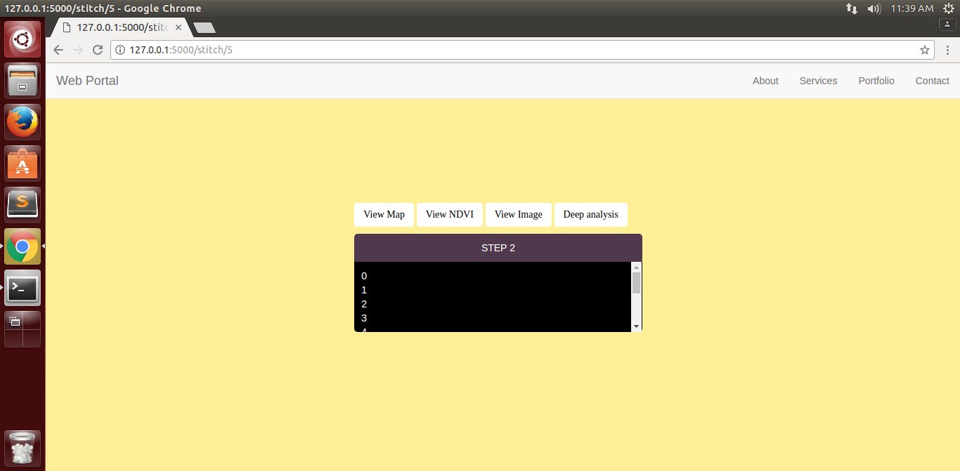

Figure 5.1 Dashboard for Image analysis

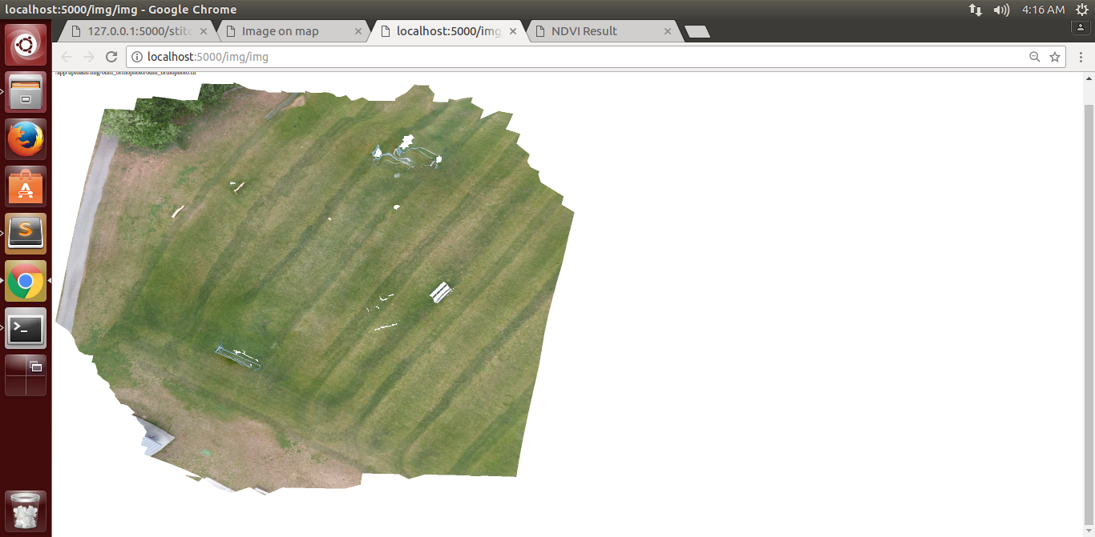

Figure 5.2: Stitched Image output

Analysis 1 Tab: Clicking on this button evaluates the newly created NDVI CSV file via the Softmax Model to divide the input image into different colour coded regions as shown below:

C:\Users\HP\Desktop\app\photo\sample_output.tif

C:\Users\HP\Desktop\app\photo\out8.tif

Figure 5.3: Stitched Image Figure5.4: Colour coded regions

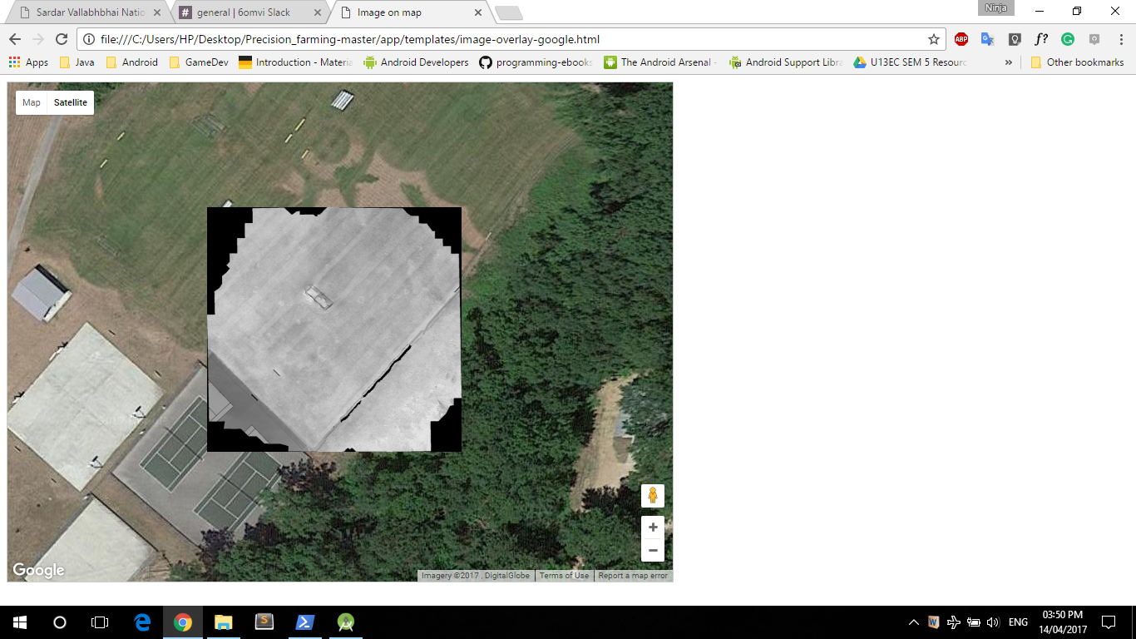Finally the image of the farm is overlaid over the Google Maps as shown:

Figure 5.5 NDVI analysed image on Google Map

Analysis Tab 2: Clicking on this button asks the user to upload an image of the crops (taken by smartphone or drone) which is evaluated against the trained inception v-3 model.

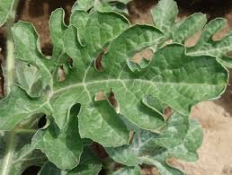

Figure 5.6: Input image of crop

Example input image as shown in figure 5xxx gives the output: Class 12: **Grape Black Rot, Guignardia bidwellii (crop-disease pair).**

**Once the disease is known the farmer gets more information on the website itself as shown:**

**Cause: “Grape black rot** is a fungal disease caused by an ascomycetous fungus, ***Guignardia bidwellii***, that attacks grape vines during hot and humid weather”

**Control**: A mixture of cultural and chemical control practices can manage grape black rot disease caused by *Guignardia bidwellii*. Cultural control aspects involve the basics in plant care and field sanitation as well as clean-up after an infectious outbreak. Chemical control has a large influence to eliminate disease.